**Scenario 1 (Solution)** :

The bank wants to apply a discount to loan interest rates for customers above 60 years old.

◉ Question: Write a PL/SQL block that loops through all customers, checks their age, and if they are above 60, apply a 1% discount to their current loan interest rates.

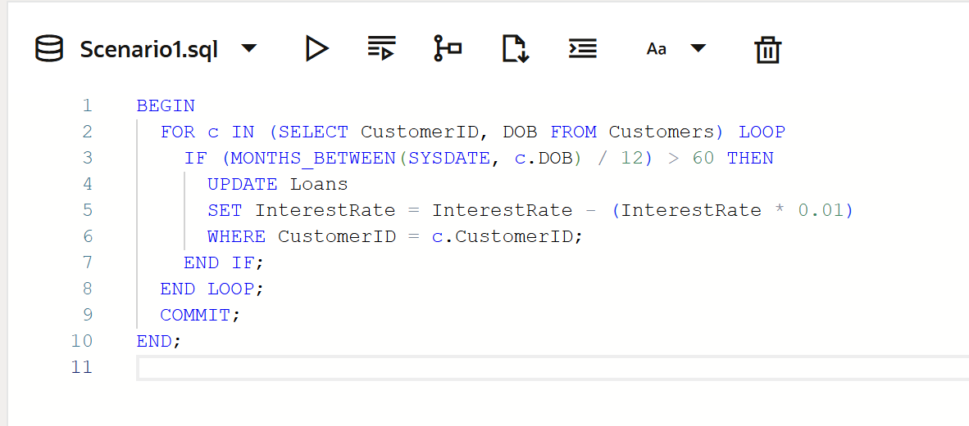

**Scenario 2 (Solution)** :

A customer can be promoted to VIP status based on their balance.

◉ Question: Write a PL/SQL block that iterates through all customers and sets a flag IsVIP to TRUE for those with a balance over $10,000.

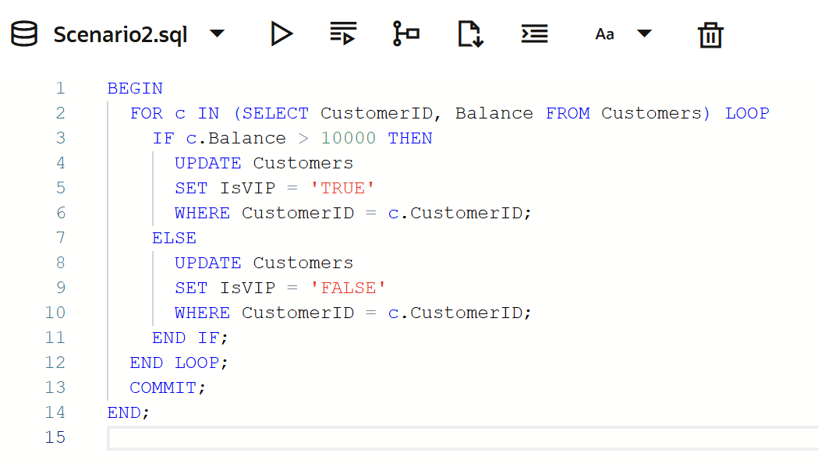

**Scenario 3 (Solution)** :

The bank wants to send reminders to customers whose loans are due within the next 30 days.

◉ Question: Write a PL/SQL block that fetches all loans due in the next 30 days and prints a reminder message for each customer.

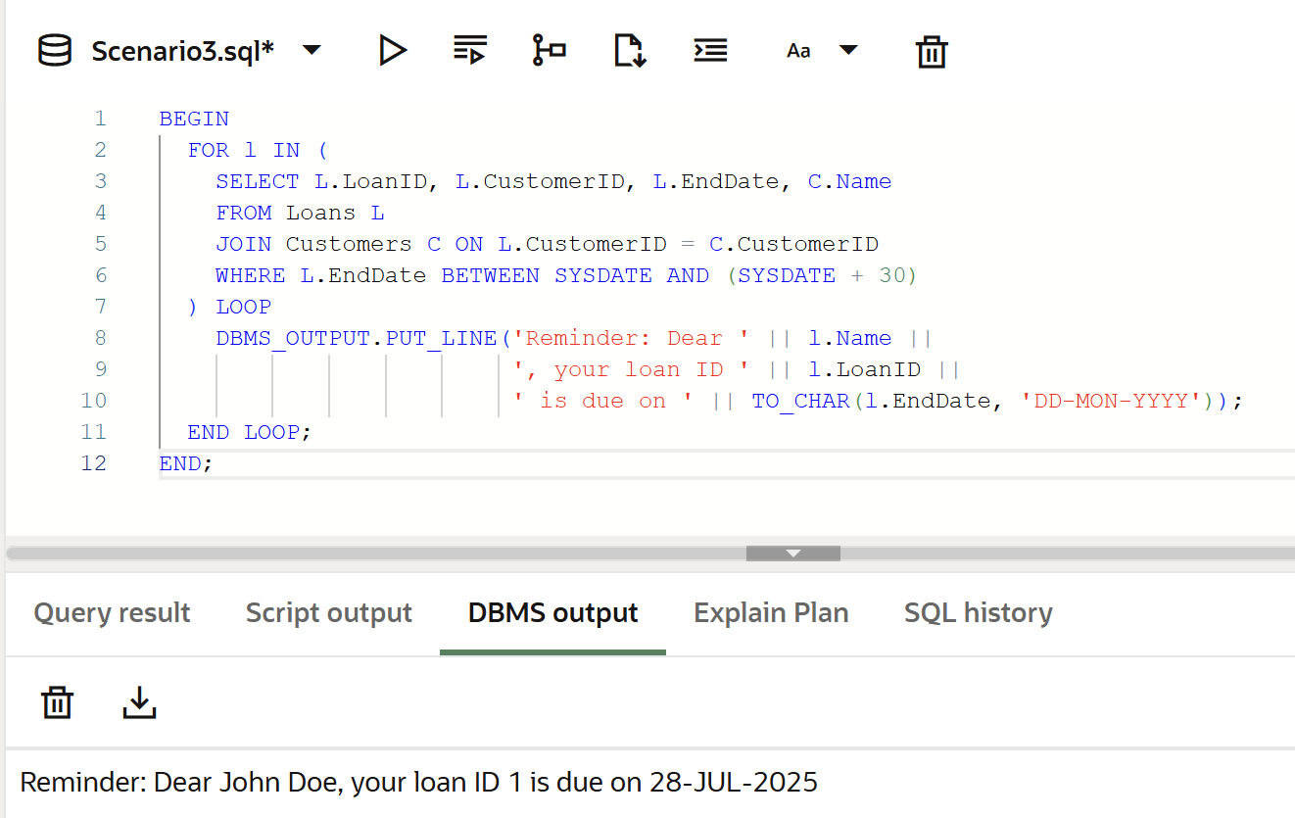

The above PL/SQL codes for scenarios1,2&3 are tried and tested by me in Live- -SQL Oracle website.